Mount in Café and Amenity Centre
Mount in Café and Amenity Centre in Malayalppuzha is a micro enterprise started in 2014 out of an unusual Pilgrim Amenity Centre built by District Tourism Promotion Council. Kudumbashree unit took over the operations and converted it into a Tourist Amenity Centre .They is of 6 members from 2 NHG’s. Amenity centre includes café, training centre, AC residential training hall and stay.

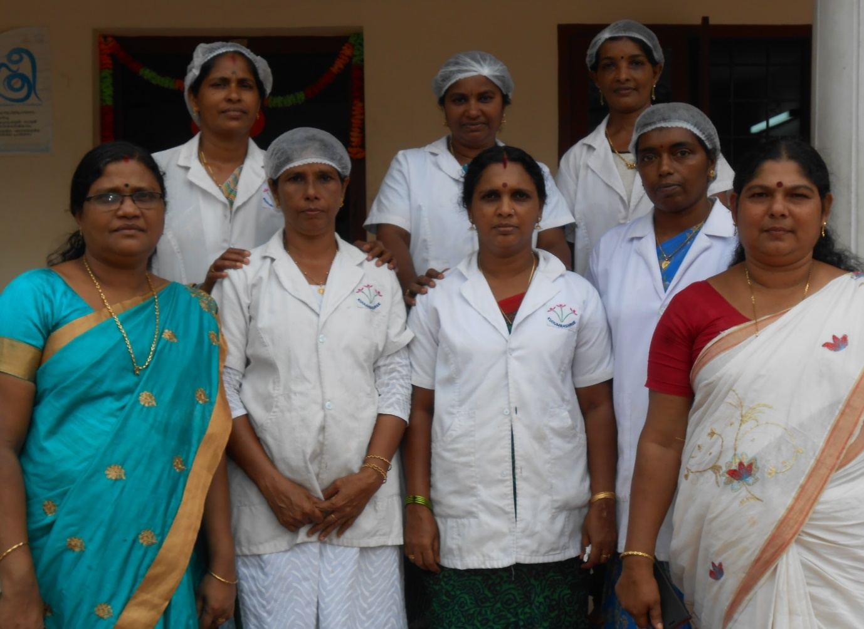
Members: - LathaPrakash, Sujatha Anil, PushpaLakshmanan, Latha Manoj, LathaKumari, Sheeba, Leelamma
The project was the result of three way convergence between the District Mission, Panchayat and DTPC. The amenity centre has 8 rooms, 1 dormitory and a conference hall besides kitchen and cafe. The café is also providing catering services for betrothal, birthday parties and other small functions. They earn around 1 lakh rupees in a month from food and other revenue from amenity centre. The total investment for the amenity centre was around 20 lakhs. The success factor is the strict adherence to quality and purity good customer service, training and continuous monitoring.

